

**Netball Code of Conduct 2013**

In order for all players, coaches and parent supporters to have a positive Netball season there is a code of conduct which must be signed by both player and parent and adhered to at all times.

Year 4/5/6 Netball has a focus on skill development and participation. It works on a rotational basis, therefore every Thursday competition game, all players must change positions at half time.

***KIWI NETBALL ROTATION POLICY***

*(as per* ***Hamilton City Netball Centre May 2011 Newsletter for Primary and Intermediate Schools****).*

*Year 4, 5 and Year 6 will play Kiwi Netball. Year 6 teams will still play kiwi Netball, with your only rotation taking place at half time.*

# *Kiwi Netball*

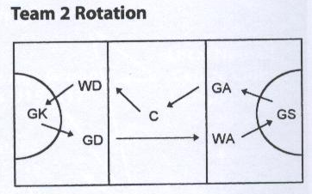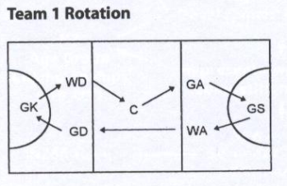

***Kiwi Netball Rotation***

*At half time all players change positions. Any player may be substituted at half time. An ill or injured player may be substituted at any time. The substitution must always take the position of the player replaced.* ***No player*** *may play in the same position twice in the game* ***unless*** *replacing an ill or injured player. If your team is printed first in the paper draw, you are Team 1. Team 1 is always on the top of the score card.* ***Please check*** *as these may change from week to week.*

*Year 6 to year 8 play on full size goals (height 3.05m or 10 ft), and use a size 5 netball.*

*Year 7 and 8 teams will play regular Netball for the whole season. Games will be four quarters. Each quarter will be ten minutes, with 1 minute to change at quarter time and half time, and two minutes between games.*

* Year 7 and 8 Netball has a competitive focus. It is a stepping stone to secondary Netball, therefore players and parents must allow the coach to play the team combination he/she believes is the best suited to the game each week. It may be that your child does not get as much game time in a particular week as another child, but over the season should even out so that each player has had the same amount of time on court.
* Once practise days and times have been organised with each team, players are expected to turn up to each practise on time, unless there is a genuine reason and the coach has been informed about this. If a player does not turn up to a practise and has not informed the coach he/she can expect to be stood down for the next competition game.

NB: Practises are about developing skills, working on set play and team combinations, and often a time when the coach discusses key points for Saturday’s game. The Parents are to advise the coach/manager should the student been running late to games or unable to attending games/trainings.

* All players are to be on time to competition games (both Thursday afternoons and Saturday mornings), allowing at least 30 mins for warm-up and skills practise before the game.
* No student will take the court without appropriate footwear and uniform for competition play.
* There will be no derogatory language used on/off the court. Positive reinforcement and encouragement from all players only.
* Netball uniforms are to be looked after and returned at the end of the Netball season in the condition they were lent out. If this is not the case the school has the right to ask for a fee to cover the cost of the damage / loss of the uniform. (Do not place skirts or dresses in the dryer).
* All team bags (including balls and equipment) should be well looked after by all team members and returned at the end of the season in the condition they were issued out at.
* On a competition day players should take instruction / coaching tips from the coach / manager in charge only. Parents should not interfere with this, as this only confuses the player. Parents are great supporters to have on the side line – so let’s keep it like that.
* All players are to encourage and support one other and work towards building a great team spirit.
* All players, parents, coaches and managers are to respect the other team. They are fellow netballers who allow a game to take place.
* Players / Parents are to show respect towards coaches / managers at all times. They put an enormous amount of time into the team.
* If there is no parental support with umpiring, the coach/manager has the right to ask each player for a small monetary contribution to cover the cost of a whistler. Because of the competitive nature of Year 7/8 Netball a competent umpire is required. It is not desirable for the coach to be the umpire except in an emergency situation.
* While Player of the day/match awards are a great way of encouraging excellent skills and attitudes in Netball the player of the day trophy (inside each team bag) or a certificate is considered a sufficient reward. Please share this award throughout the team so no student misses out.
* Selection of a captain for Year 7 and 8 teams will be decided upon by the coach of each team should the coach decide there is to be one.

I agree to abide by the Marian School Netball Code of Conduct rules for 2011.

**Player Name ______________________ Player Signature:____________________**

**Parent Name _______________________ Parent Signature:____________________**

**Coach Name: _______________________ Coach Signature: ____________________**

**Manager Name: _____________________ Manager Signature: __________________**